|  |  |
| --- | --- |
| **Digital Forensics**  Diploma in CSF/IT  Year 2/3 (2020/21) Semester 4/6 | Week 1 |
| Practical 1 |
| **Familiarization with EnCase** | |

**OBJECTIVES**

1. To be familiarized with EnCase environment
2. To be able to navigate and carry out simple function in EnCase

Preparation:

1. Boot the computer to Windows 7.
2. Start EnCase application.
3. You should see the panel showing “**EnCase Forensic Training**” rather than “EnCase Acquisition”.

If you see “EnCase Acquisition”, carry out the following steps to troubleshoot. Otherwise, move on to Part A.

* 1. Enable the wired network adapter and set the IP address to dynamically assigned.
  2. Ping 10.1.0.1 and ensure that you receive replies from the SAFE server.

**Part A: Case Management**

**Important notes:**

* **All evidence files that will be used in this module are stored in “C:\Evidence Files”.**
* **Always copy the required evidence files to your own case folder before you start the investigation.**
* **You should stay at the same workstation throughout the semester.**

In Encase, a case is stored in a folder, with subfolders for case-specific information such as search results. The case folder and the components contained within that folder directly associate the investigative work you perform.

Encase automatically creates several folders when the case is created. These folders include:

* Documents
* Email
* Export
* Searches
* Tags
* Temp

When a device or evidence file is added to the case, the EvidenceCache folder is created.

1. Launch EnCase by clicking the icon
2. When you launch EnCase, the Home page will display:

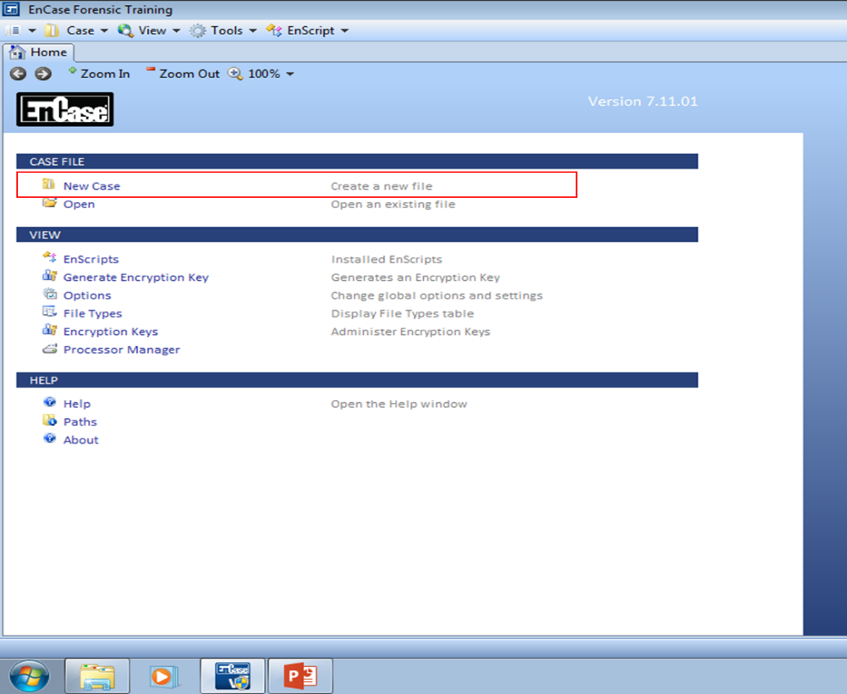

Figure A-1: Home Page

To create a new case:

1. Click **New Case** beneath the CASE FILE category
2. The Case Options dialog displays. Use this dialog to select a case template and name the case.
3. In the figure below, the #1 Basic template is selected.
4. Enter a case Name, then click OK.

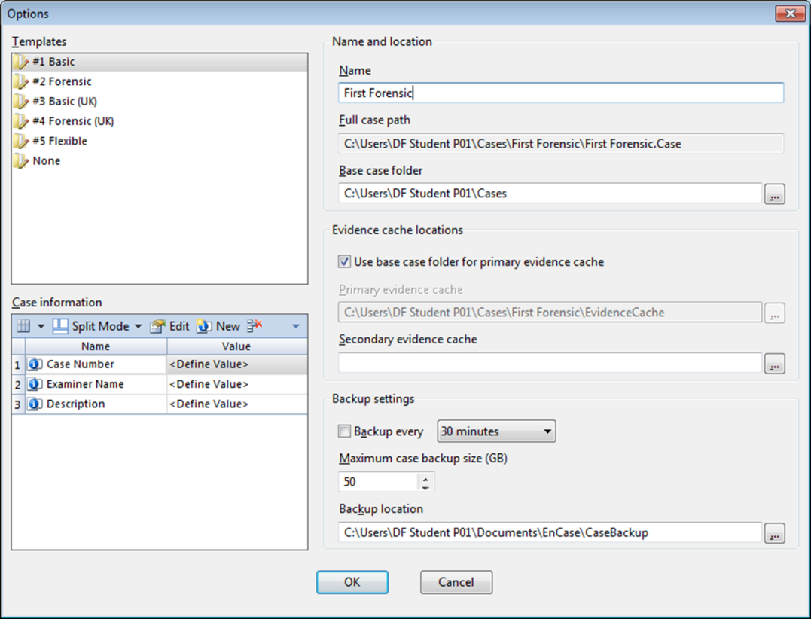

Figure A-2: Case Option Dialog

For this week, we shall use the Name called “First Forensic”.

**Full case path:** The folder in which the case file is stored. This path is determined by the Base case folder, followed by a subfolder with the case name.

**Base case folder:** The location where the above case folder is created.

No back-up is needed in this exercise.

Q1: What do you understand about the .Case file?

.Case file is a file that store information of the case you are doing. For example, the temple, base folder and etc.

**Part B: Adding Evidence to a Case**

Click OK to continue. The following display will appear:

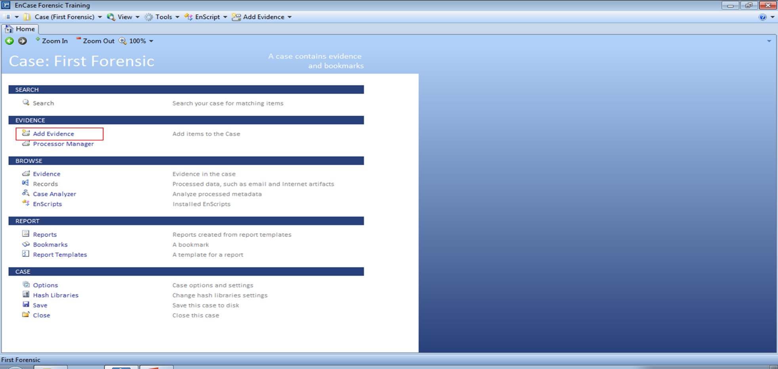

Figure B-1: Case Page List

Select **Add Evidence.**

You will need to add an evidence file to navigate. Hence, next select **Add Evidence File**

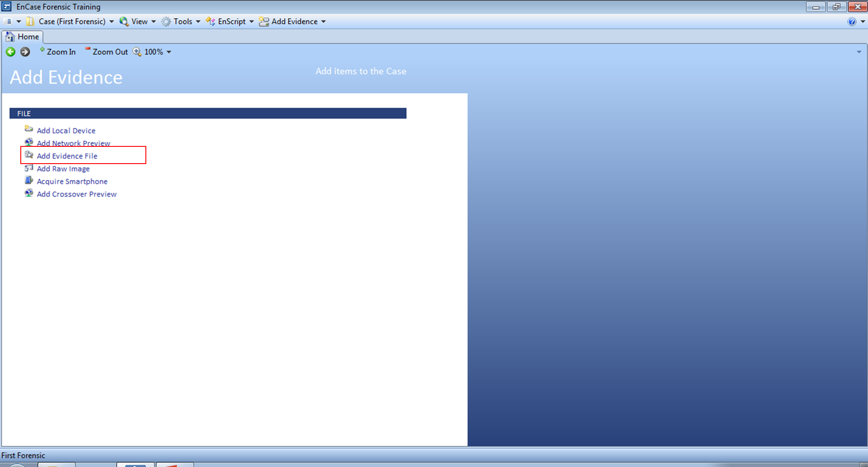

Figure B-2: Add Evidence Menu

Navigate to where the evidence file is stored (i.e. C:\Evidence Files\First Forensic\) and add the First Forensic.E01. Highlight the evidence file and click open.

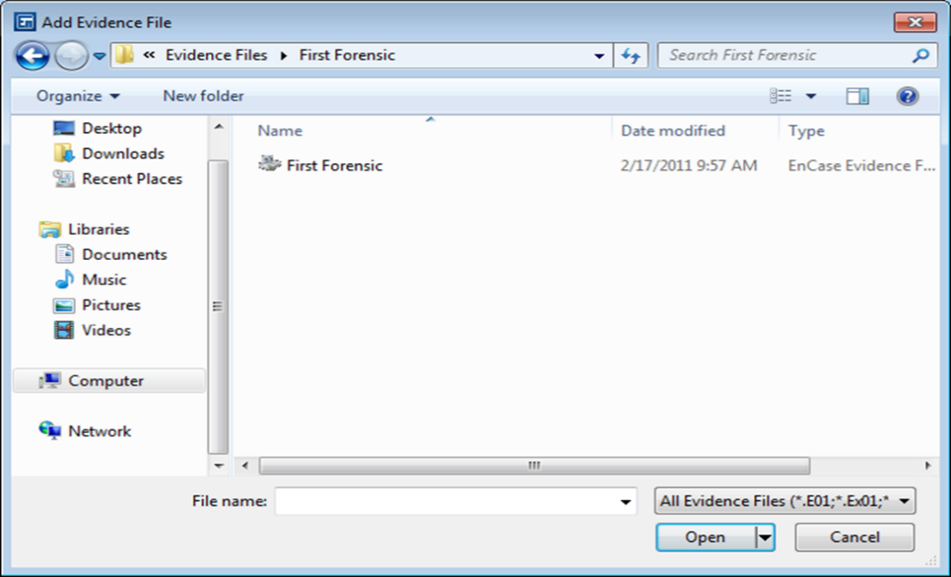

Figure B-3: Evidence file

The Viewing (Evidence) screen will appear.

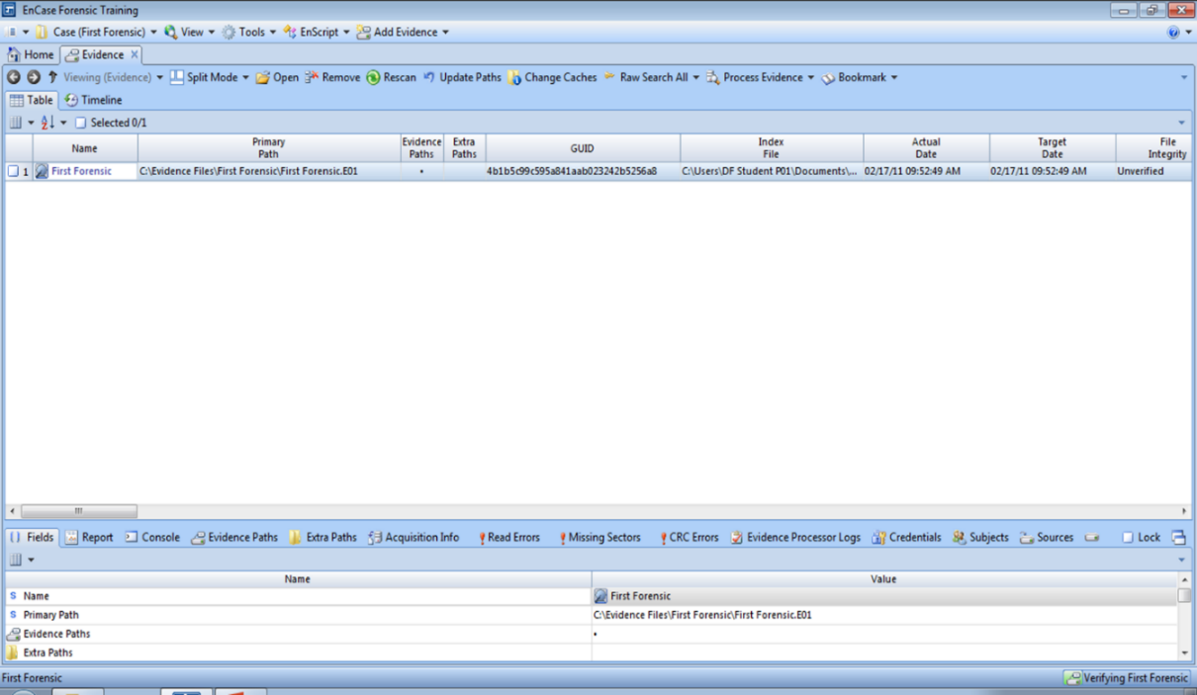

Figure B-4: Viewing (Evidence) screen

Q2: In what way do you think this evidence file was generated?

Evidence can be generated through bit by bit imaging after connected to a write blocker to a forensic machine.

Blue check the First Forensic evidence item entry and click **Open** or double click the 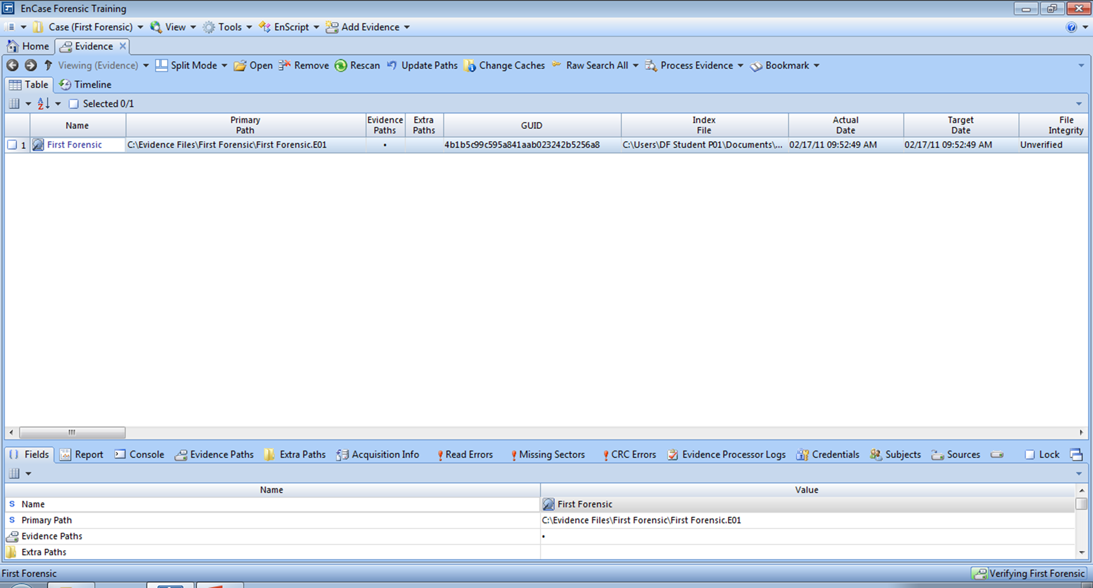 icon.

The evidence will load and be cached automatically. Once this process is completed, you will be brought to the Viewing (Entry) screen.

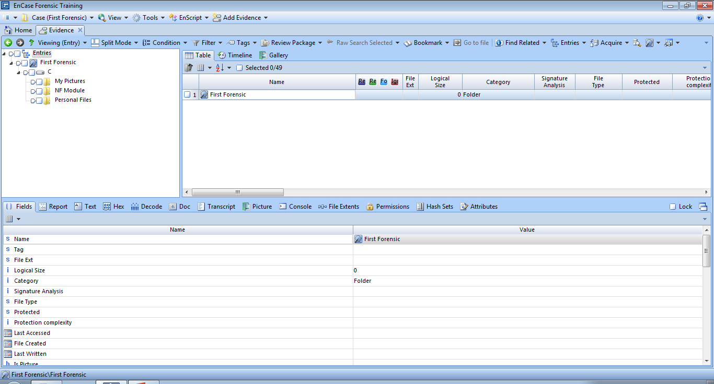

Figure B-5: Viewing (Entry) screen

**Part C: Navigating the EnCaseEnvironment**

The screen is initially divided into 3 sections:

* Tree Pane
* Table Pane
* View Pane

The Tree-Table shows the **Tree pane** on the left, the **Table pane** on the right, and the **View pane** on the bottom. This is the traditional EnCase entries view.

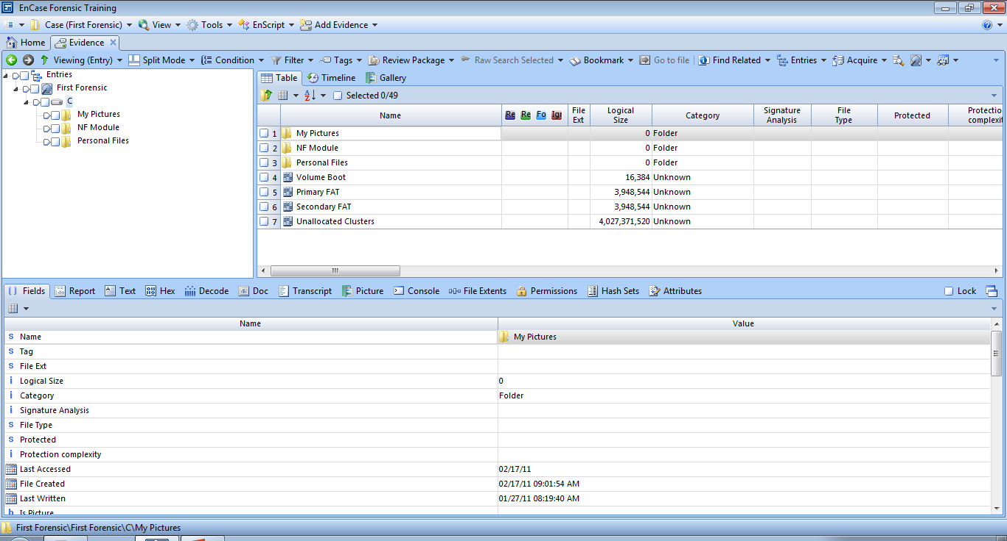

**Table Pane**

**View Pane**

**Tree Pane**

Figure C-1: View of three panes

**Tree Pane**

**Filter Pane**

The Tree view presents the evidence in a standard hierarchical folder structure. Only evidence files and the folders contained within them are displayed in this view. Individual files are displayed in the Table Pane. The arrows can be used to expand and contract the tree structure just as they are used in Windows Explorer.

Right-click on an object in the Tree Pane will bring up a context menu.

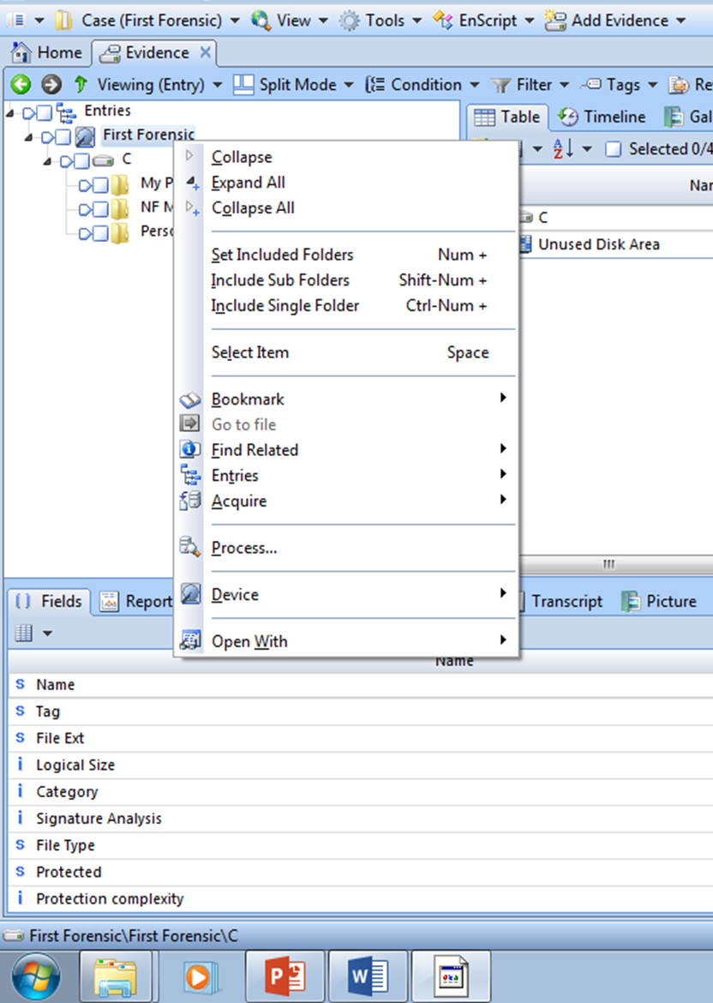

Figure C-2: Context Menu

There are 3 methods used within EnCase to focus on specific files or folders. These methods have different purposes:

* **Highlighting** a folder displays the entries within that folder in the Table Pane. This is used **for viewing** information only.
* The **Set Include Option** method displays all the entries, files, and folders for that folder and subfolders in the Table Pane. It overrides the highlighting option. This is used **for viewing** information only.

When a folder is included, the other folders are grayed out. All files and folders within the folder and subfolders are displayed in the Table Pane. To deactivate this function, click on the **Set Include Option** icon again or click twice on another include icon.

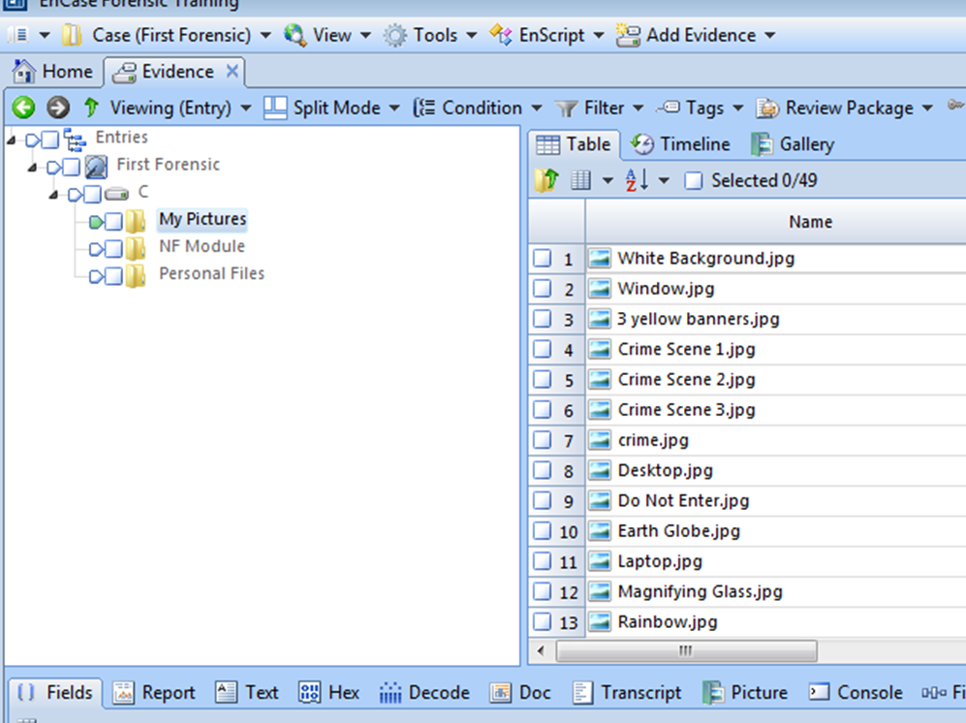

Figure C-3: “Set including” a Folder Structure

* The **Blue-check** [](http://www.dreamstime.com/register?jump_to=http://www.dreamstime.com/stock-images-blue-tick-symbol-image7330424)or **Select for future action** method is used for designatin [](http://www.google.com.sg/imgres?q=blue+tick+images&um=1&hl=en&sa=X&biw=1167&bih=562&tbs=isch:1&tbnid=WaNI2XJlRnIkbM:&imgrefurl=http://www.dreamstime.com/stock-images-blue-tick-symbol-image7330424&imgurl=http://www.dreamstime.com/blue-tick-symbol-thumb7330424.jpg&zoom=1&w=400&h=400&iact=hc&vpx=826&vpy=242&dur=1413&hovh=225&hovw=225&tx=100&ty=158&ei=0loRTZuWBYyjcaaWjMcK&oei=yloRTdSkIMHTrQe83f3KCw&esq=4&page=4&tbnh=120&tbnw=115&start=55&ndsp=21&ved=1t:429,r:19,s:55) [](http://www.google.com.sg/imgres?q=blue+tick+images&um=1&hl=en&sa=X&biw=1167&bih=562&tbs=isch:1&tbnid=WaNI2XJlRnIkbM:&imgrefurl=http://www.dreamstime.com/stock-images-blue-tick-symbol-image7330424&imgurl=http://www.dreamstime.com/blue-tick-symbol-thumb7330424.jpg&zoom=1&w=400&h=400&iact=hc&vpx=826&vpy=242&dur=1413&hovh=225&hovw=225&tx=100&ty=158&ei=0loRTZuWBYyjcaaWjMcK&oei=yloRTdSkIMHTrQe83f3KCw&esq=4&page=4&tbnh=120&tbnw=115&start=55&ndsp=21&ved=1t:429,r:19,s:55)g files or folders on which **to perform an analysis operation** such as keyword search. This can be implemented from a variety of views.

[](http://www.google.com.sg/imgres?q=blue+tick+images&um=1&hl=en&sa=X&biw=1167&bih=562&tbs=isch:1&tbnid=WaNI2XJlRnIkbM:&imgrefurl=http://www.dreamstime.com/stock-images-blue-tick-symbol-image7330424&imgurl=http://www.dreamstime.com/blue-tick-symbol-thumb7330424.jpg&zoom=1&w=400&h=400&iact=hc&vpx=826&vpy=242&dur=1582&hovh=225&hovw=225&tx=132&ty=158&ei=0loRTZuWBYyjcaaWjMcK&oei=yloRTdSkIMHTrQe83f3KCw&esq=4&page=4&tbnh=120&tbnw=115&start=55&ndsp=21&ved=1t:429,r:19,s:55)The **Dixon Box** ca be found at the Table Pane that indicates how many entries have been selected.

To deselect all entries, click within this Dixon box to remove the blue check,

Try out these options.

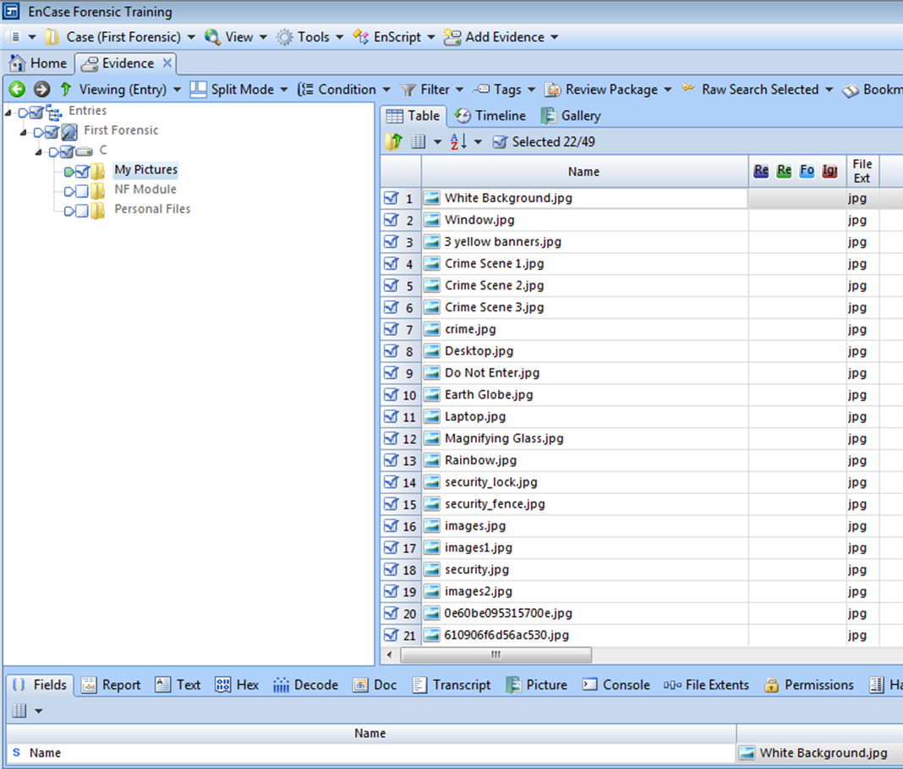

Figure C-4: “Blue-checking” entries and the Dixon Box

**Table Pane**

The Table Pane consists of three views:

* Table View,
* Timeline View and
* Gallery View.

By default the Table Pane is in the Table View. Within this view are the subfolders and file objects that are contained within the folder(s) and are highlighted or included (Set Include) in the Tree Pane.

Highlighting an object in the Table Pane displays the object’s location in the Status Bar (bottom left-hand corner)



The Table view in the Table Pane displays many columns of information about the displayed entries, notable, Name, File Ext, Logical Size, Category, Signature Analysis, File Type, Protected, etc.

The Timeline View in the Table Pane shows patterns of different types of dates and times.

The Gallery View in the Table Pane displays images in thumbnail view. These images are displayed (by default) based on their extension.

**Filtering Your Evidence**

Filters are EnScripts that provide a table view of all entries that match a particular set of criteria. Filters do not remove any items from the case; they simply specify which entries are shown in the Table pane.

Depending on what tab is currently selected, different types of filters are available. For example, the filters available for search hits are different from those available for entries.

EnCase comes with a number of preconfigured default filters for your use.

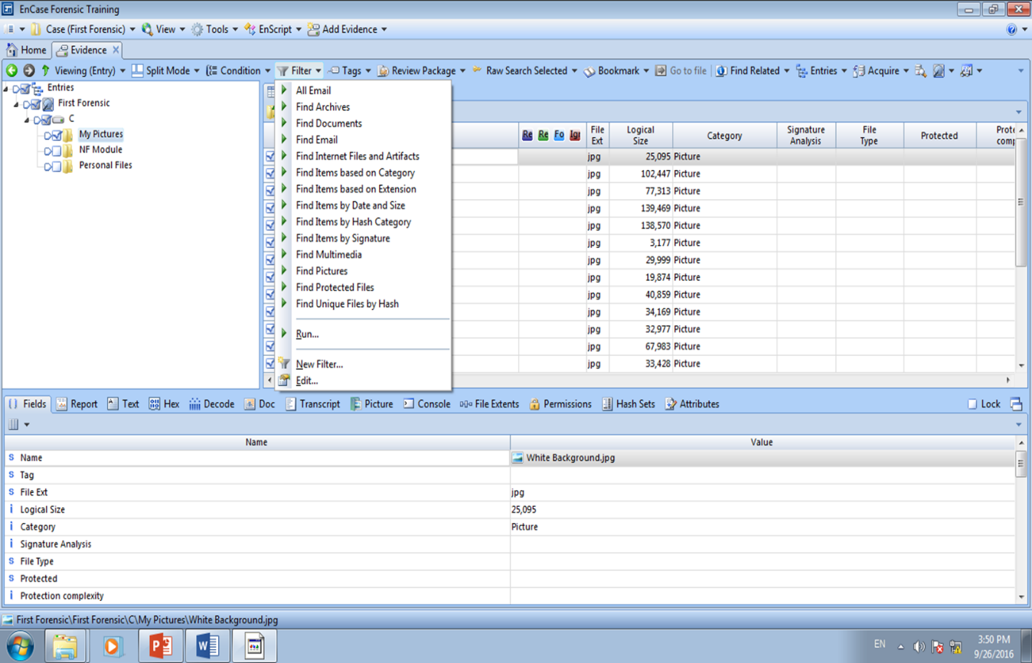

Figure C-5: Table 🡪 Filter

Click the Filter dropdown menu on the toolbar. A list of filter options will be available for selection. Select the desired filter you want (e.g. ‘Find Pictures’). The Filter dialogs will appear:

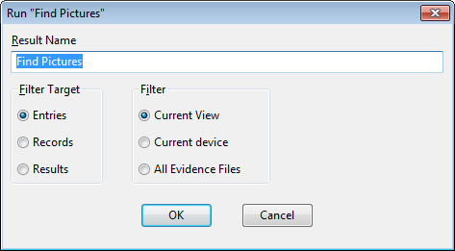

Figure C-5: Table 🡪 Filter Options

Click Current View (or All Evidence Files – to run through all the evidence in the case)

Click OK to run the filter. Depending on which filter you selected, additional dialogs may display. When a filter is being run, if Current View is selected, another screen (Table view) will appear showing the name of all the filtered selections.

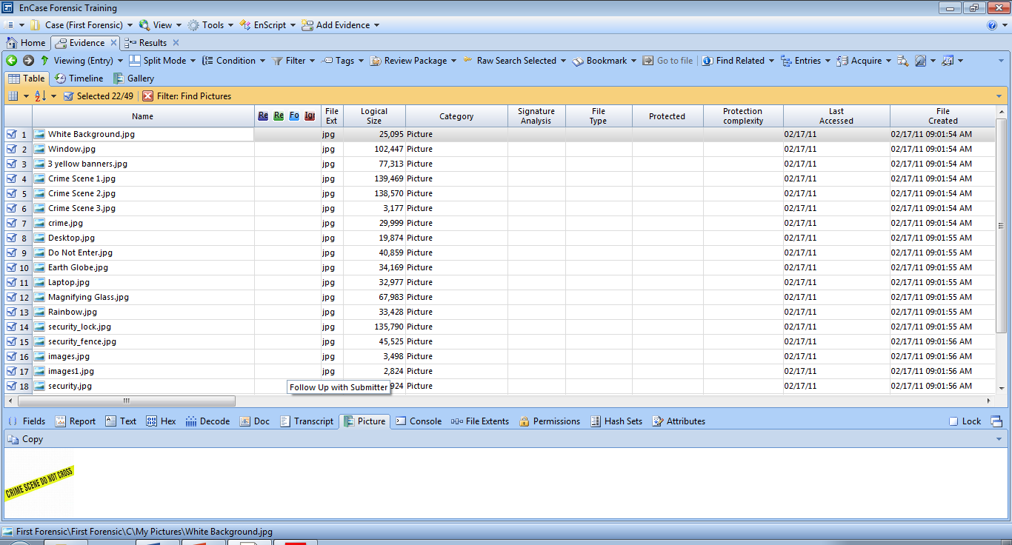

Figure C-6: Table 🡪 Filter Selections

If All Evidence Files option is selected, the results will be shown in the Results tab.

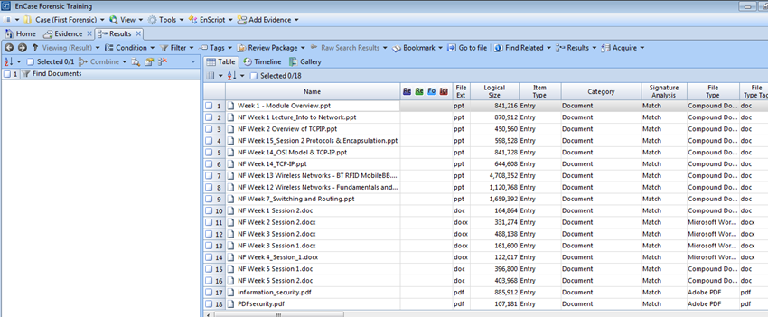

Figure C-7: Table 🡪 Filter Selections (Results Tab)

**View Pane**

The View Pane displays the contents of the item highlighted in the Table Pane. The View pane provides several ways to view file content:

* The *Fields tab* displays all information available regarding an item. All fields shown on this tab are indexed.
* The *Report tab* provides a readable, formatted view of metadata.
* The *Text tab* displays files in ASCII or Unicode text.
* The *Hex tab* displays files as straight hexadecimal.
* The *Decode tab* lets you decode swept data in the Hex tab in a variety of different formats. You can then make that sweeping text into a bookmark.
* The *Doc tab* provides native views.
* The *Transcript tab* displays the same formats as the Doc tab, but filters out formatting, allowing you to view files that cannot display effectively in the Text tab.
* The *Picture tab* displays graphics files.
* *File extents* shows the sector information about the selected file. This works on entry evidence only.
* The *Permissions t*ab displays the security permissions for a file, including the name and security identification number (SID) of the user(s) who have permission to read, write, and execute a file.
* *Hash sets* show hash information for entry evidence only.

EnCase checks the contents of the file highlighted in the Table Pane to see if it is an image that can be decoded internally. If so EnCase will provide the ability for the user to select the Picture view in the View Pane and display the image.

If numerous files highlighted in the Table Pane are images, EnCase will default to the Picture view for subsequent images. Likewise, if a Microsoft Word document is highlighted, Encase will change the default view in the View Pane to Text.

If the examiner wishes to have every highlighted item displayed in the Hex or Text view, he need to click on the square box beside **Lock** to lock that view.

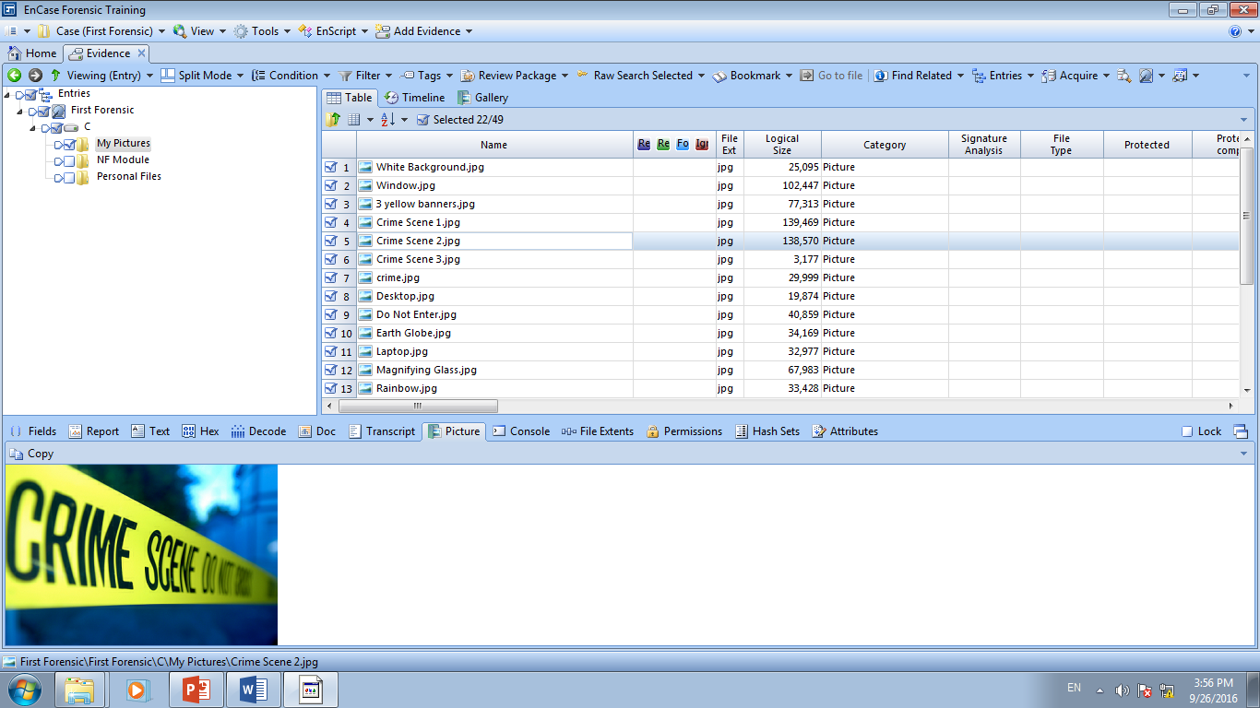

Figure C-8: Picture view in View Pane

To unlock, remove the blue check from the box.

Here is the same picture viewed in hexadecimal.

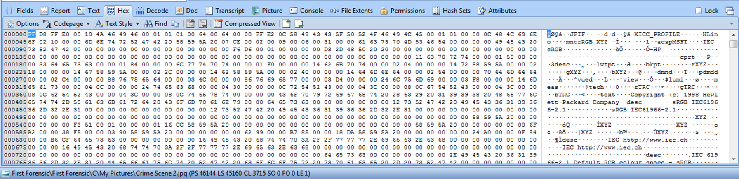

Figure C-9: Viewing in the View Pane as Hex

Here is a word file displayed in Doc view.

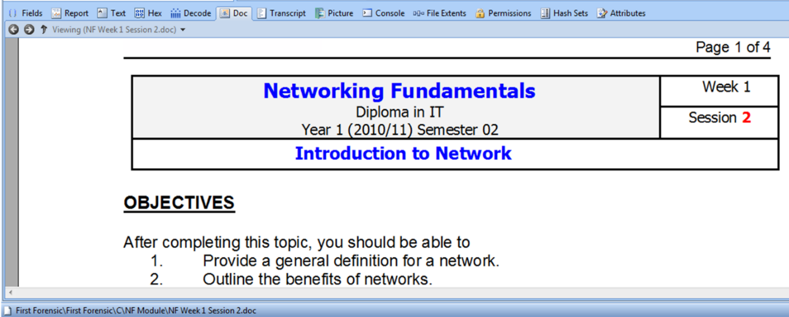

Figure C-10: Viewing in the View Pane as Doc

A ppt file displayed in Doc view.

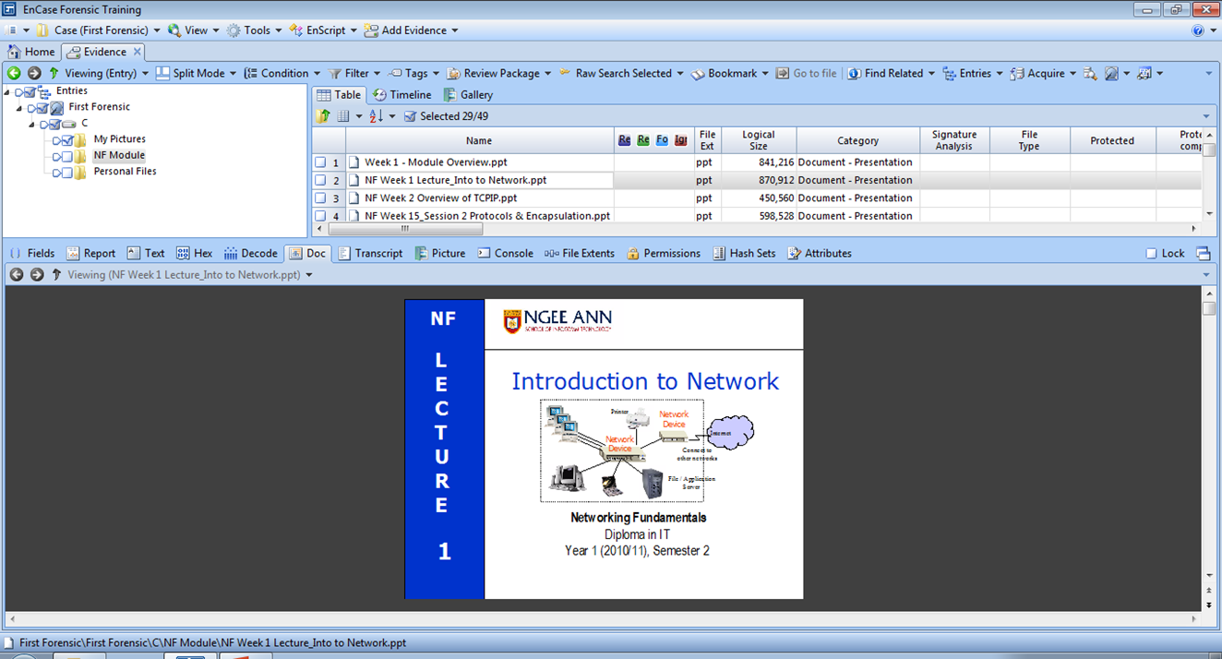

Figure C-11: Viewing in the View Pane as Doc for Powerpoint file

Q3: What are the 2 ways to view pictures/images in EnCase?

In the view panel, you can view images as Picture or Doc

The text format may be improved by altering the text style from the **Text Styles** tab in the Filter Pane.

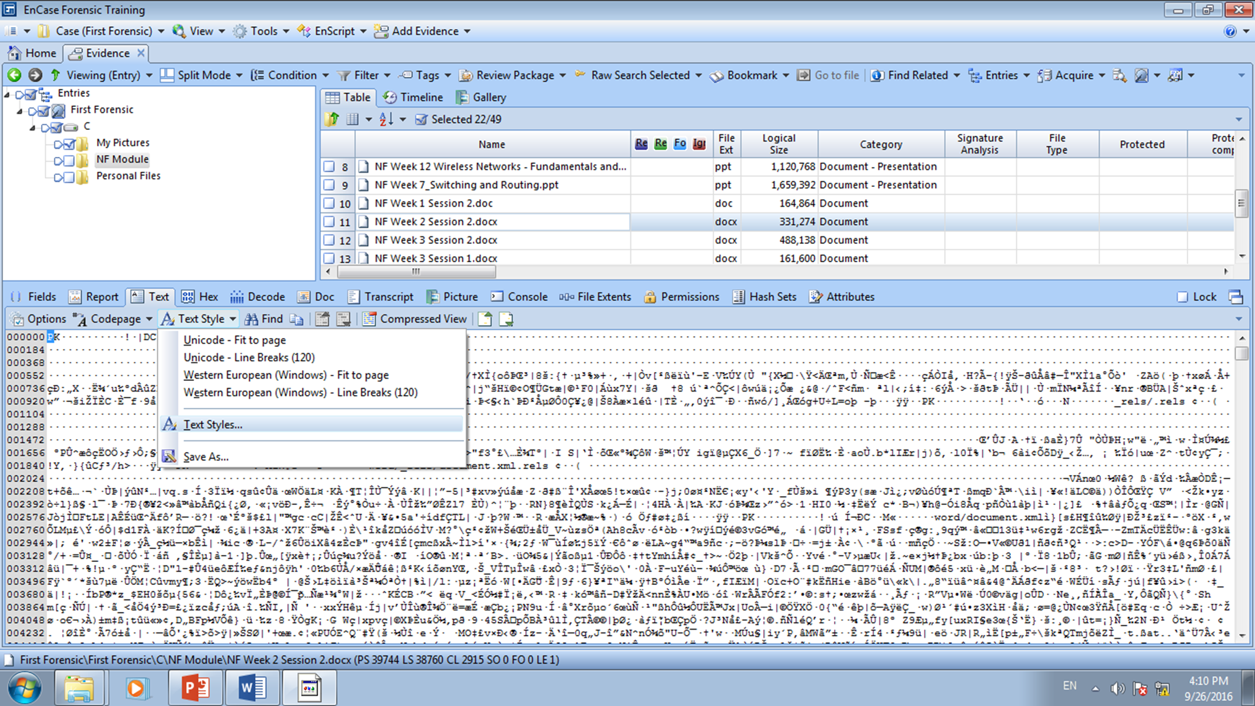

Figure C-12: Changing text style for View Pane

Q4: Do some research to find out more about the following character representations.

|  |  |  |
| --- | --- | --- |
|  | Character Representation | Description |
| 1 | ASCII | A 7bit character encoding standard. ASCII codes represent text in computers, telecommunications equipment, and other devices. |
| 2 | ISO Latin | A 8 bit character set endorsed by the International Organization for Standardization (ISO) and represents the alphabets of Western European languages |
| 3 | Unicode | Unicode is a universal character encoding standard. It defines the way individual characters are represented in text files, web pages, and other types of documents. |

The status bar found at the bottom of the screen provides information on the current position within a case.



Figure C-13: Status Bar

The codes are translated as follows:

**PS** Physical sector number

**LS** Logical sector number

**CL** Cluster number

**SO** Sector Offset – The distance in bytes from the beginning of the sector

**FO** File Offset – The distance in bytes from the beginning of the file

**LE** Length – The number in bytes of the selected area

Q5: Look for a file named *Rainbow.jpg* and record the following.

|  |  |
| --- | --- |
| PS | 46888 |
| LS | 45904 |
| CL | 3808 |
| SO | 0 |
| FO | 0 |
| LE | 0 |

Q6: Why is it important to know the current position within a case?

The position is use as a physical evidence where we can state the exact location of the evidence.

It is important to be aware of one’s current positioning within the case especially when documenting the location of evidence found in unallocated space. For data found in unallocated space, examiner uses the above information for documenting the evidence.

Reflection: What have you learnt through this practical exercise?

I learn how to navigate encase software and the use of file current position

Reference

* Guidance Software, Inc, *EnCaseComputer Forensics II* – v7.1psvi.

- The End -